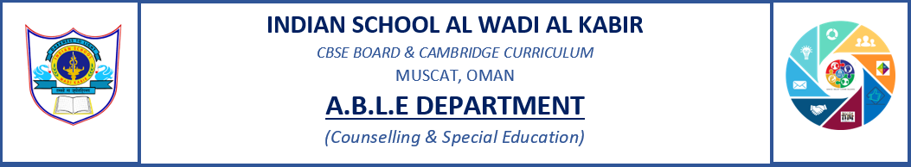
INCLUSION Sessions

ISWK - PRIMARY SECTION ( Grade 1 - 5)

The A.B.L.E Department conducted a workshop in collaboration with the value ed. And class teachers on Inclusion from 21/08/2022 to 25/08/2022.The session was conducted for Grades 1-5.
The objectives of this workshop were;

1) To introduce inclusion and its meaning.
2) To make them understand why inclusion is important.
3) To develop empathy and not sympathy towards the differently abled sections of our society.
3) To encourage students to share their ideas on how they will implement inclusion in their day
today life.

The outcomes of the workshop were;

- Students actively participated in the discussion and shared their views.
- Students shared their personal experiences on bullying and ways to overcome bullying.
- Students also discussed and supported the idea of equality in the classroom.
- Students enjoyed and happily participated in the given activity.

